Uploading and linking to documents using the Visual Editor

Step 1: Go to the Media Library

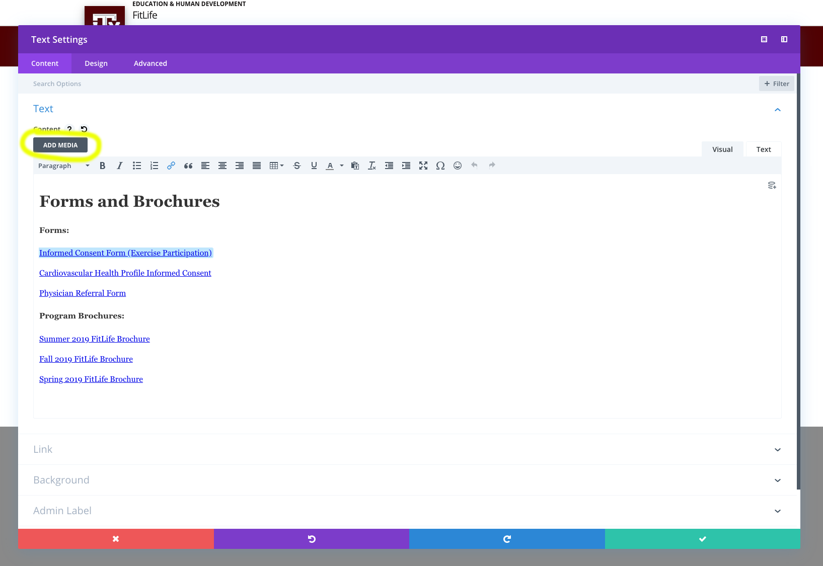

- Make sure the Visual Builder is enabled
- In the text editor, click Add Media

Step 2: Upload your document(s)

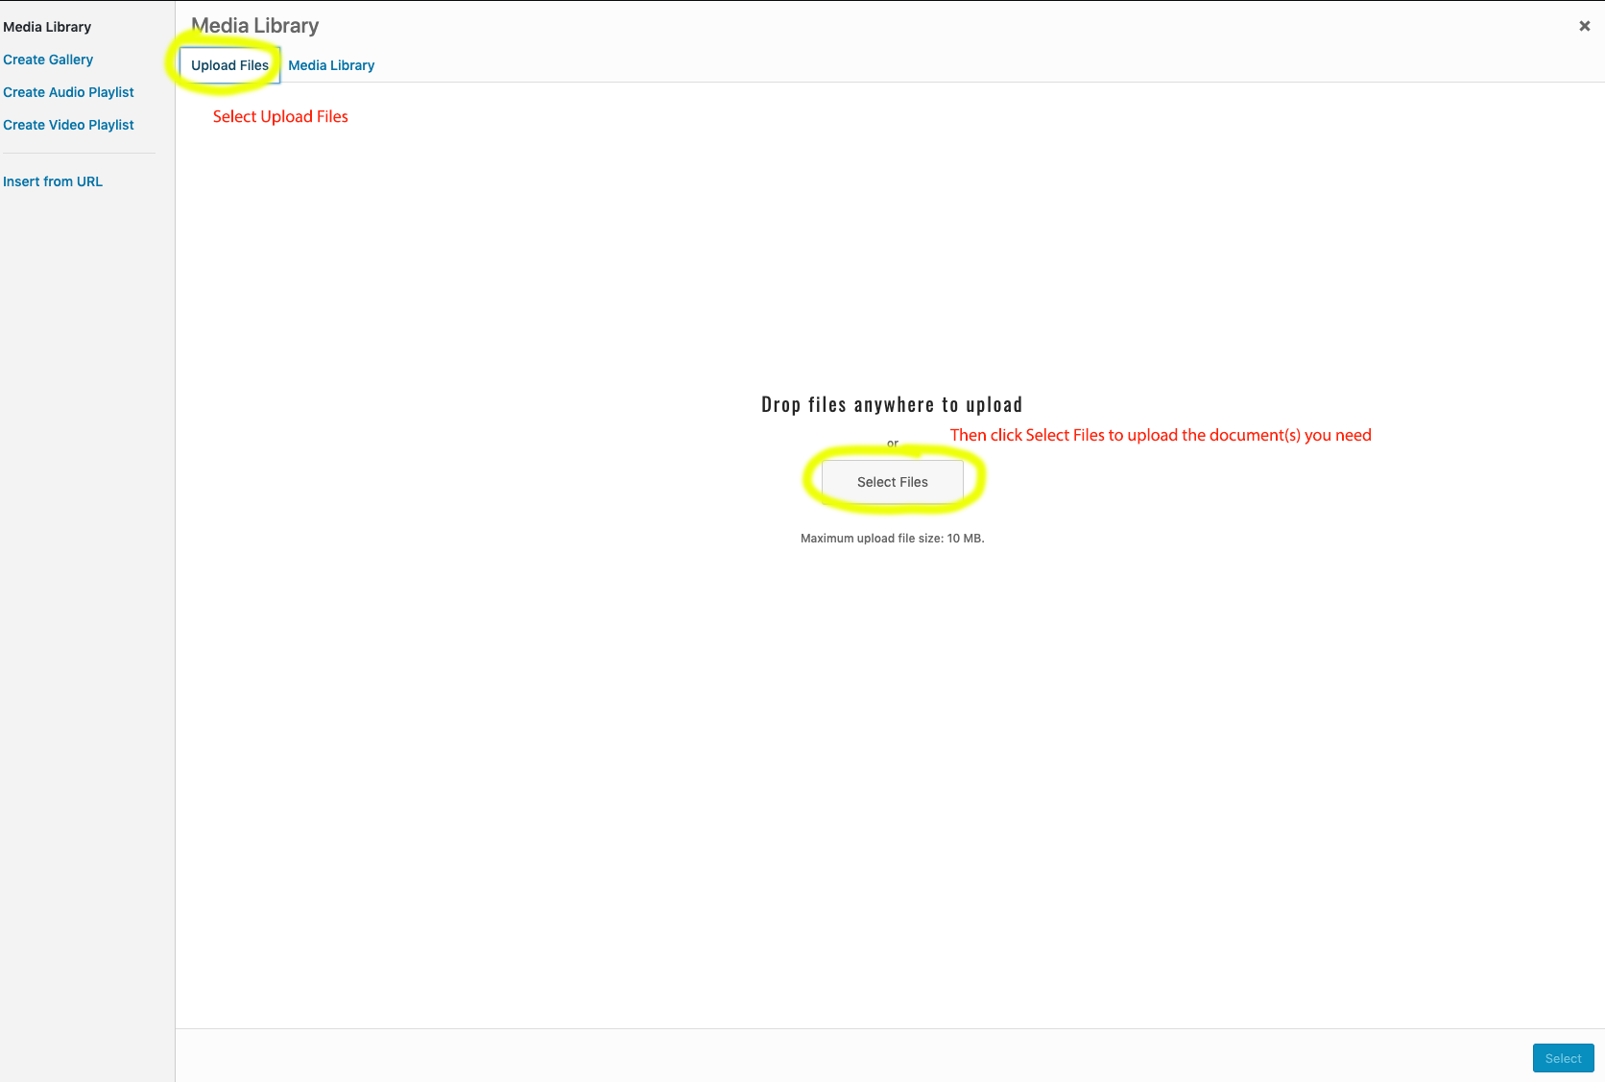

In the Media Library, select Upload Files, then click Select Files to upload the document(s) you need.

Step 3: Select the file you want to link to

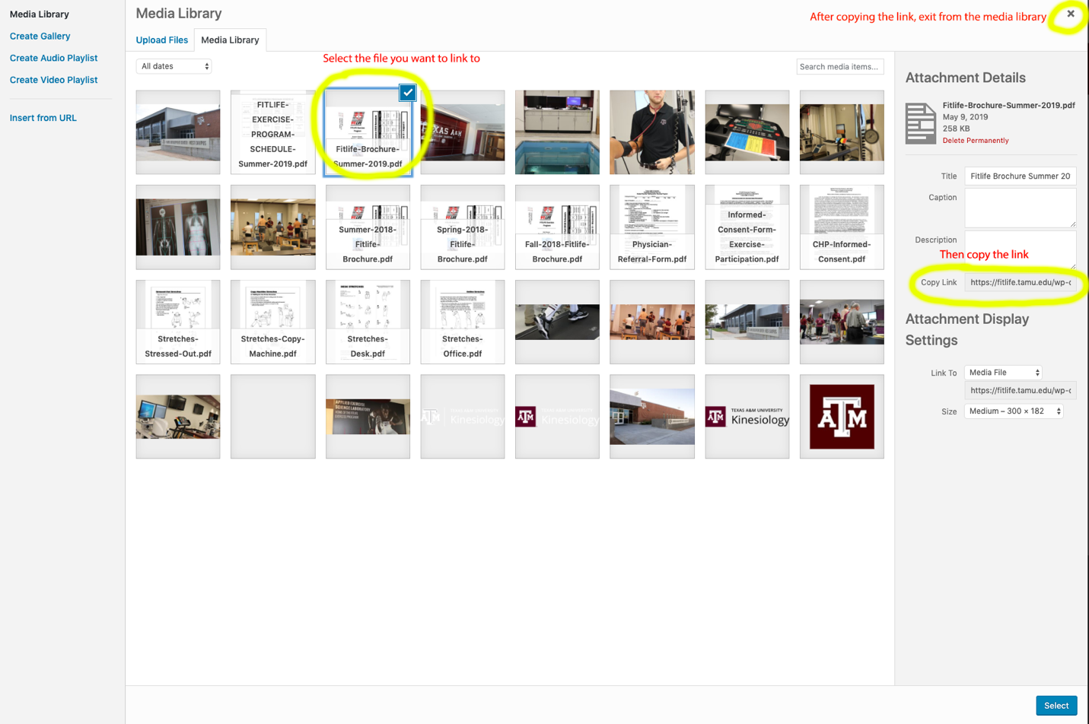

- Select the file you want to link to – it should be outlined in blue with a check mark
- Under Attachment Details, copy the file link
- After copying the link, exit out of the Media Library using the X in the top right corner

Step 4: Add the document link in your page content

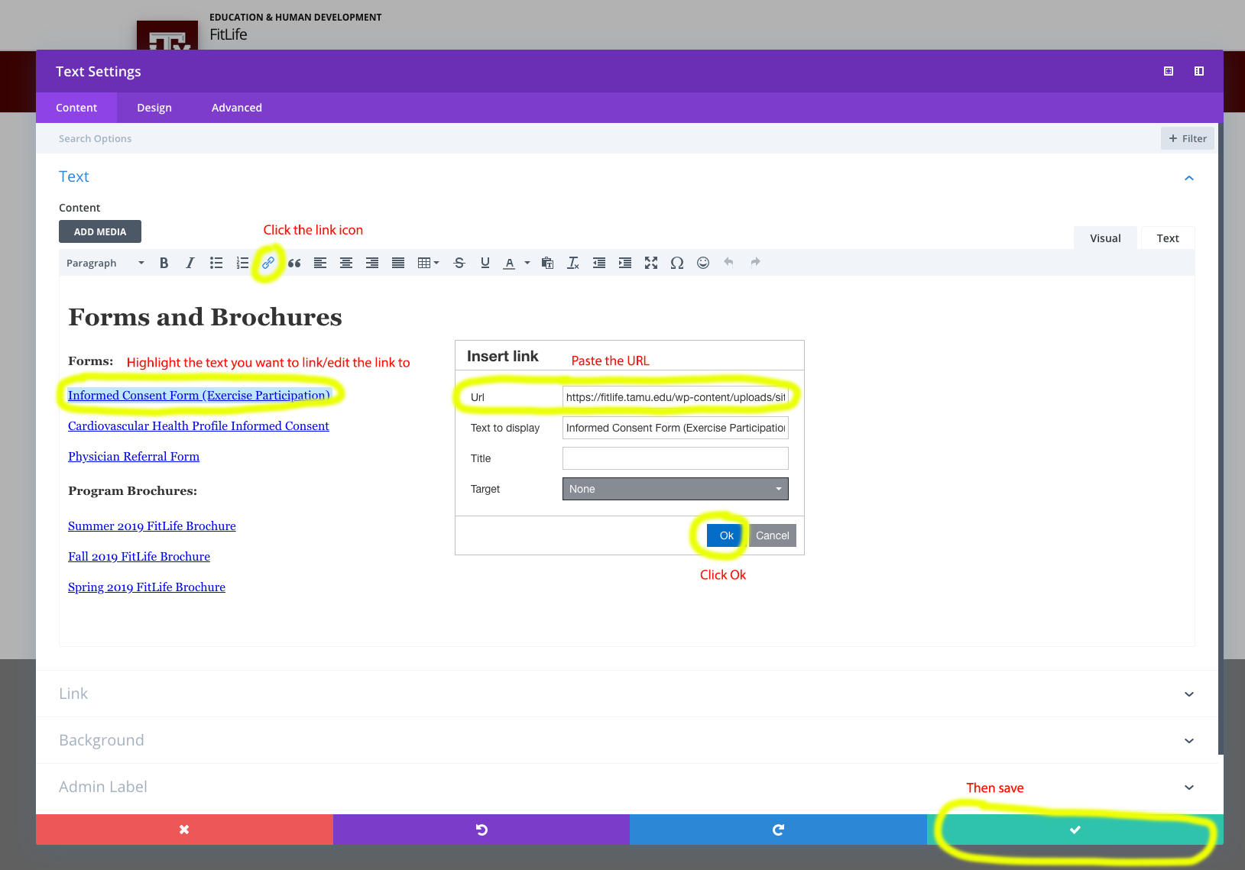

- Highlight the text you want to link to
- Click the link icon
- Paste the URL copied from the Media Library into the URL box
- Click Ok
- Make sure to save – click the green check mark

*This is the same process you will use to replace links (e.g. switching out documents that are outdated)

